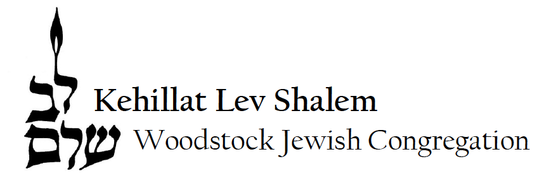
Membership Information

DATE: ________________________________________
Adult #1
Name
Date of Birth
Hebrew Name
None________/Unknown________
Email
Cell Phone
Occupation

Wedding Anniversary Date Home Phone
Adult #2
Name
Date of Birth
Hebrew Name
None________/Unknown________
Email
Cell Phone
Occupation

Address
Names and birthdates of children, even if they are adults. If you need additional room, attach another sheet of paper.
1. DOB Living with parents
Child #1 Hebrew name None________/Unknown________
2. DOB Living with parents
Child #2 Hebrew name None________/Unknown________
Would you like the office to have an emergency contact on file?
Name Relationship to you
Home phone Cell Email
Payment Information: Yes, I/we wish to join the WJC as member(s)
check enclosed charge my credit card one time charge my credit card in 10 monthly installments

Card # Exp Date (month & year) Validation Code

Cardholder’s Signature Cardholder’s Name (print)
Jewish Background
Adult 1 – Did you grow up Reform, Conservative, Orthodox, or other? __________________________
Have you belonged to a synagogue previously, and if so, where? _______________________

Adult 2 - Did you grow up Reform, Conservative, Orthodox, or other? __________________________
Have you belonged to a synagogue previously, and if so, where? _______________________

Deceased Loved Ones for Our Yahrzeit Records
Name: Family Relationship: Date of Death: I Observe:
(MM/DD/YYYY) Hebrew Gregorian
(before/after sunset)

Interests and Skills
I/We would be interested in learning about and/or possibly joining the following. Place an “X” next to any area of interest
Adult #1 Adult #2 Committee/Activities Adult #1 Adult #2 Skills/Talents/Interests
Shabbat Hosting Computer/Technology
Caring Social Networking
Ritual Music
Help out in the office Marketing/PR
Plan Holidays Grant Writing
Hebrew reading/chanting Finance
Fundraising Home Repair
Gardening Hebrew/Yiddish/Ladino
Choir Art
Are there any other skills or services you would be interested in sharing with the Congregation?

What three words best describe your ideal congregation?

What services, events, and other programs interest you?

